Liberia

## Population Data

The data set shows the political stability estimate of the country each year.

## # A tibble: 23 x 5  
## country iso3c date population popCategory5  
## <chr> <chr> <dbl> <dbl> <chr>   
## 1 Liberia LBR 1996 2160478 very small   
## 2 Liberia LBR 1997 2326202 very small   
## 3 Liberia LBR 1998 2517481 very small   
## 4 Liberia LBR 1999 2699712 very small   
## 5 Liberia LBR 2000 2848456 very small   
## 6 Liberia LBR 2001 2953927 very small   
## 7 Liberia LBR 2002 3024729 very small   
## 8 Liberia LBR 2003 3077058 very small   
## 9 Liberia LBR 2004 3135651 very small   
## 10 Liberia LBR 2005 3218116 very small   
## 11 Liberia LBR 2006 3329211 very small   
## 12 Liberia LBR 2007 3461911 very small   
## 13 Liberia LBR 2008 3607860 very small   
## 14 Liberia LBR 2009 3754133 very small   
## 15 Liberia LBR 2010 3891356 very small   
## 16 Liberia LBR 2011 4017443 very small   
## 17 Liberia LBR 2012 4135659 very small   
## 18 Liberia LBR 2013 4248334 very small   
## 19 Liberia LBR 2014 4359505 very small   
## 20 Liberia LBR 2015 4472230 very small   
## 21 Liberia LBR 2016 4586788 very small   
## 22 Liberia LBR 2017 4702228 very small   
## 23 Liberia LBR 2018 4818977 very small

# Population growth data

## # A tibble: 23 x 5  
## country iso3c date popGrowth popGrowthCat5   
## <chr> <chr> <dbl> <dbl> <chr>   
## 1 Liberia LBR 1996 5.51 high growth rate   
## 2 Liberia LBR 1997 7.39 high growth rate   
## 3 Liberia LBR 1998 7.90 high growth rate   
## 4 Liberia LBR 1999 6.99 high growth rate   
## 5 Liberia LBR 2000 5.36 high growth rate   
## 6 Liberia LBR 2001 3.64 high growth rate   
## 7 Liberia LBR 2002 2.37 moderate growth rate  
## 8 Liberia LBR 2003 1.72 moderate growth rate  
## 9 Liberia LBR 2004 1.89 moderate growth rate  
## 10 Liberia LBR 2005 2.60 high growth rate   
## 11 Liberia LBR 2006 3.39 high growth rate   
## 12 Liberia LBR 2007 3.91 high growth rate   
## 13 Liberia LBR 2008 4.13 high growth rate   
## 14 Liberia LBR 2009 3.97 high growth rate   
## 15 Liberia LBR 2010 3.59 high growth rate   
## 16 Liberia LBR 2011 3.19 high growth rate   
## 17 Liberia LBR 2012 2.90 high growth rate   
## 18 Liberia LBR 2013 2.69 high growth rate   
## 19 Liberia LBR 2014 2.58 high growth rate   
## 20 Liberia LBR 2015 2.55 high growth rate   
## 21 Liberia LBR 2016 2.53 high growth rate   
## 22 Liberia LBR 2017 2.49 moderate growth rate  
## 23 Liberia LBR 2018 2.45 moderate growth rate

## Population trend

The plot shows the population trend of the country.

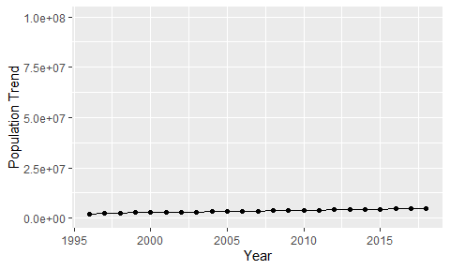

Political Stability Trend

# Population growth trend

The plot shows the population growth rate trend of the country.

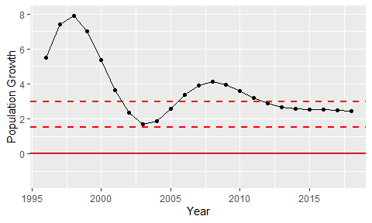

Population Growth Trend